# **Task#1:**

**Q.1.**

**Q.2.**

**Q.3.**

**Q.4.**

**Q.5.**

**Q.6.**

**Q.7.**

**Q.8.**

# **Task#2:**

**Q.1.**

The record type is A, which stands for Address Record.

**Q.2.**

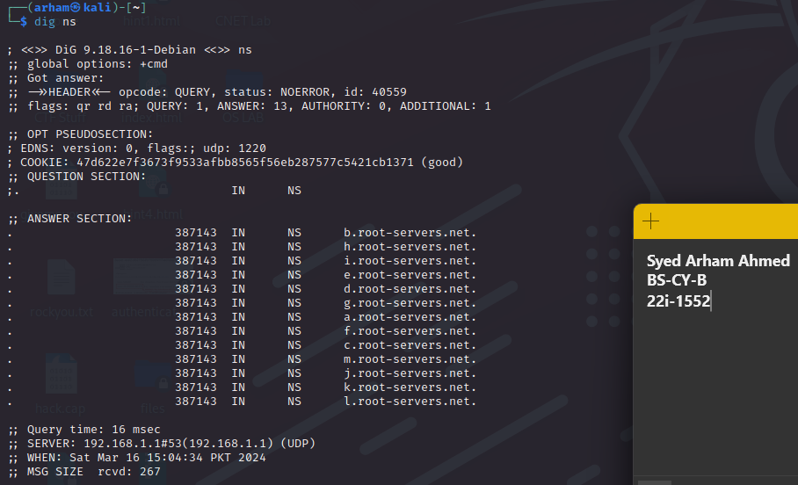

We can see 13 root servers after command dig ns.

**Q.3.**

**Q.4.**

**Q.5.**

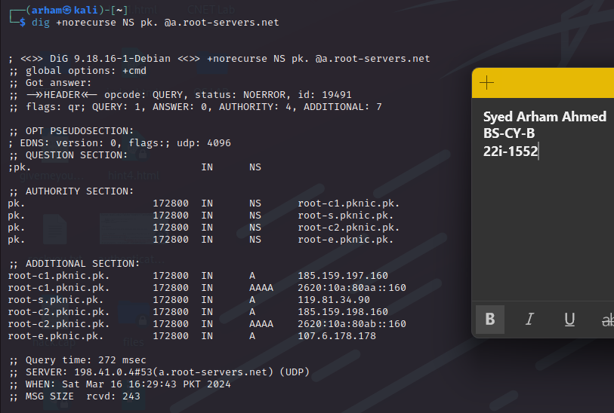

# Task#3:

**Q.1.**

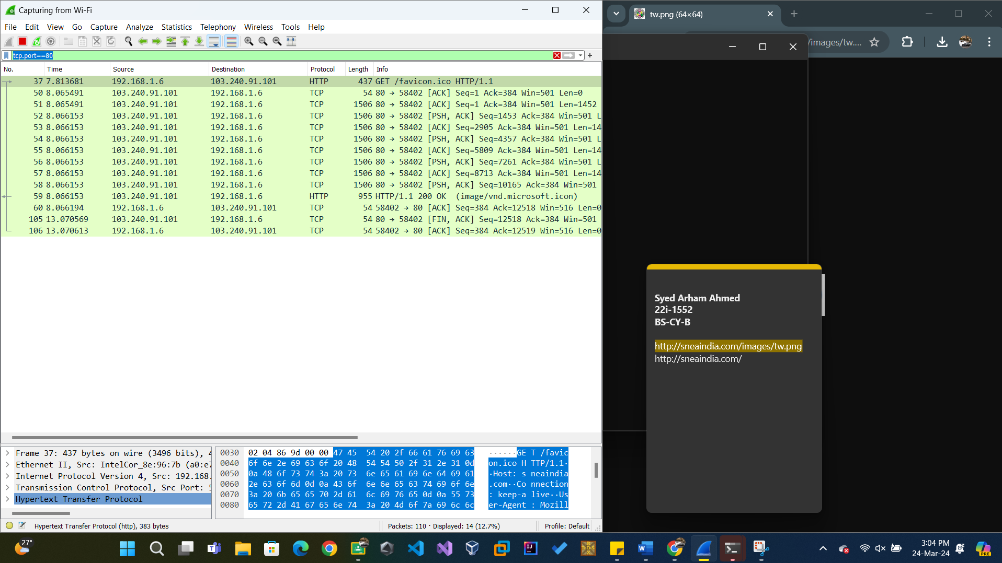

So, the difference that I noticed now is that when I re-pasted the URL is that it did not generate more than 2 more packets, this means that cache was used to fetch the URL contents, and it did not do TCP handshake again as well saving us time when re opening the URL. I can also see the HTML code of the still webpage if I follow and open HTTP stream of the packets.

Well, the static image URL did not generate many packets but the whole website generated thousands of packets as a lot more data needed to be loaded other than just still images with no embeds.

**Q.2.**

http contains "FLAG" {This command searches for the word FLAG in the TCP packets}

I ran the command listed above and it gave me the packet ie:247 which contains the flag.

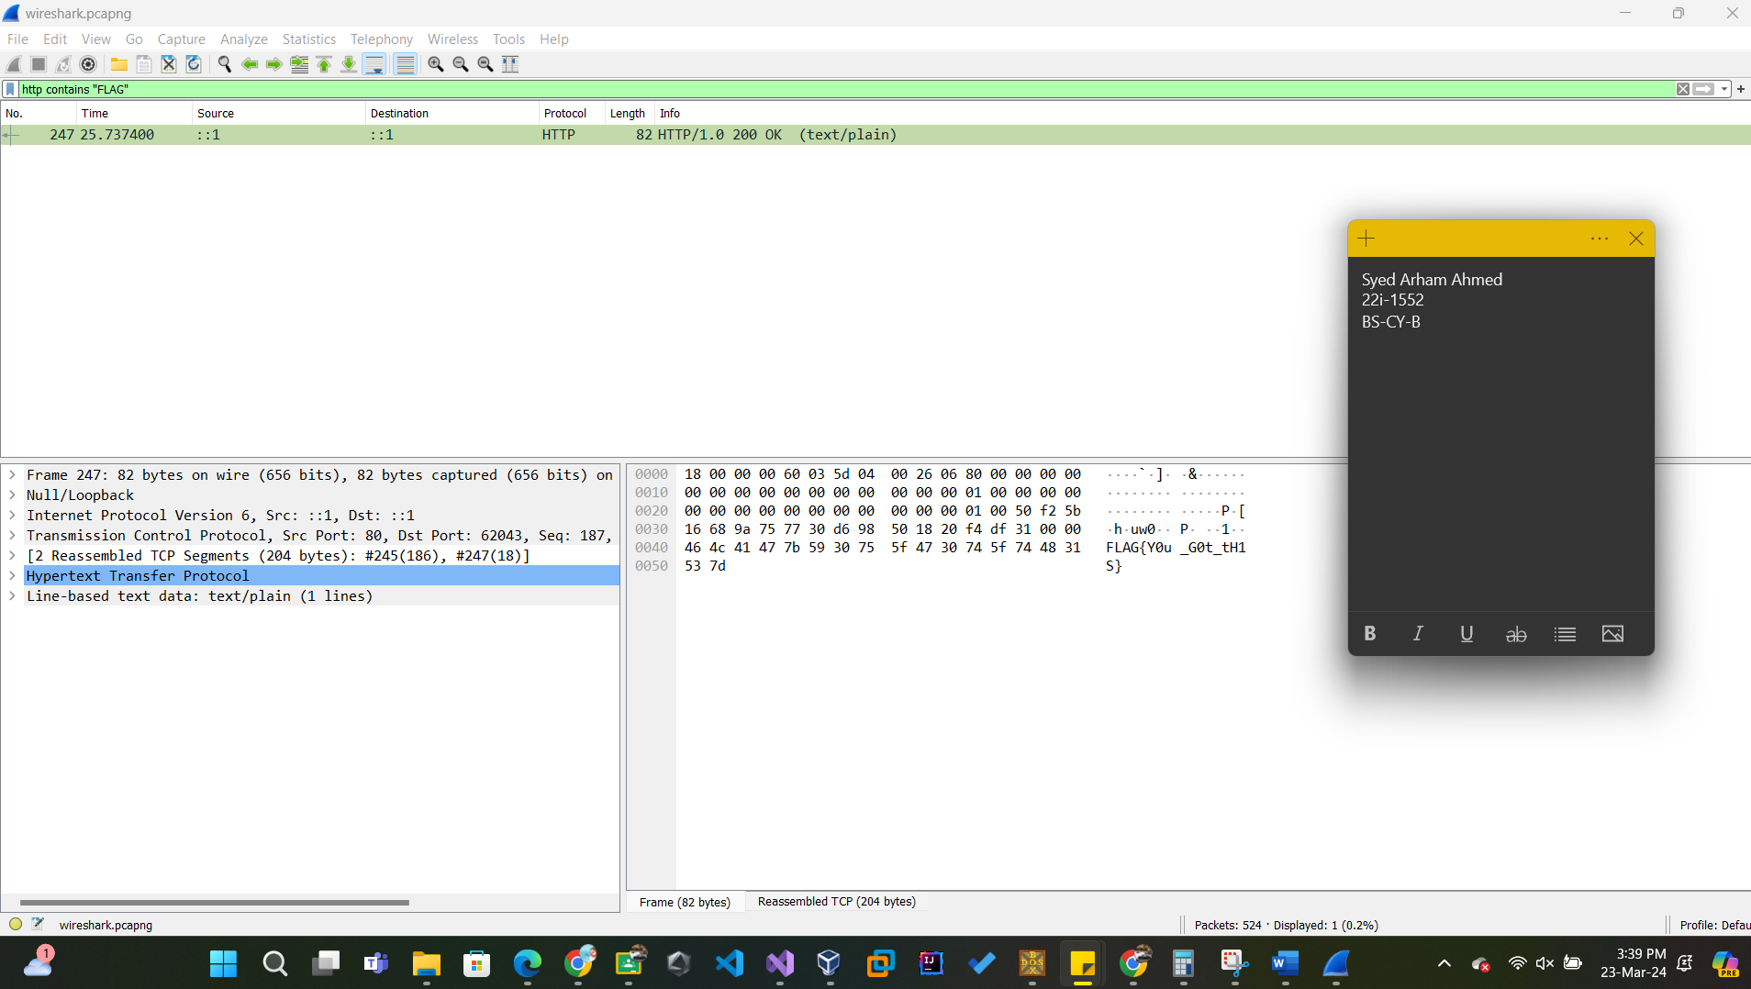

**Q.3.**

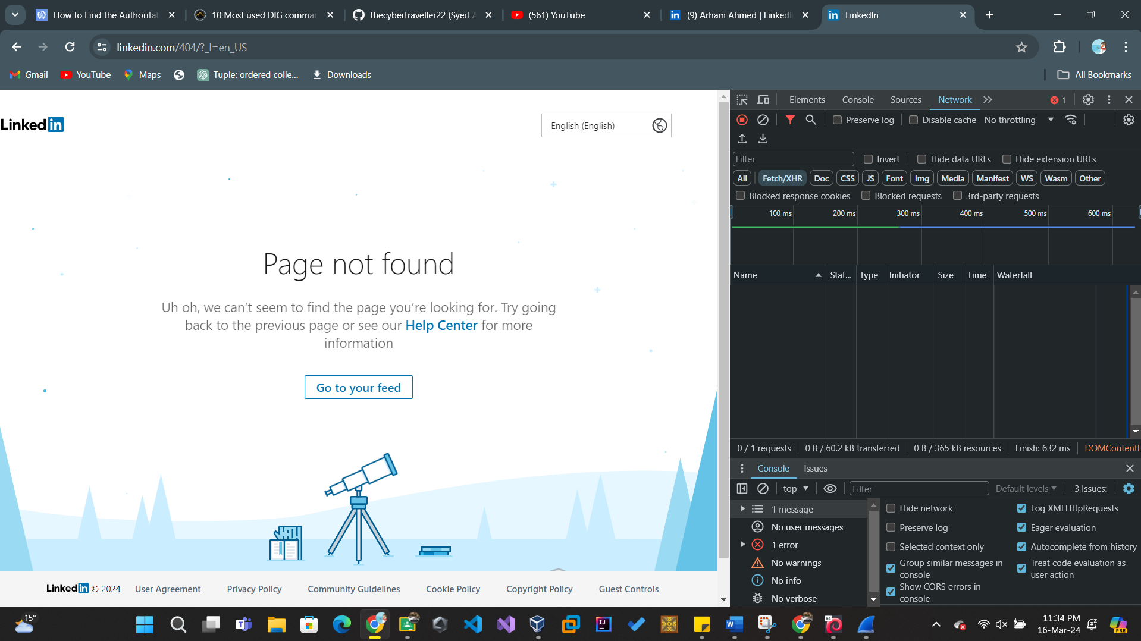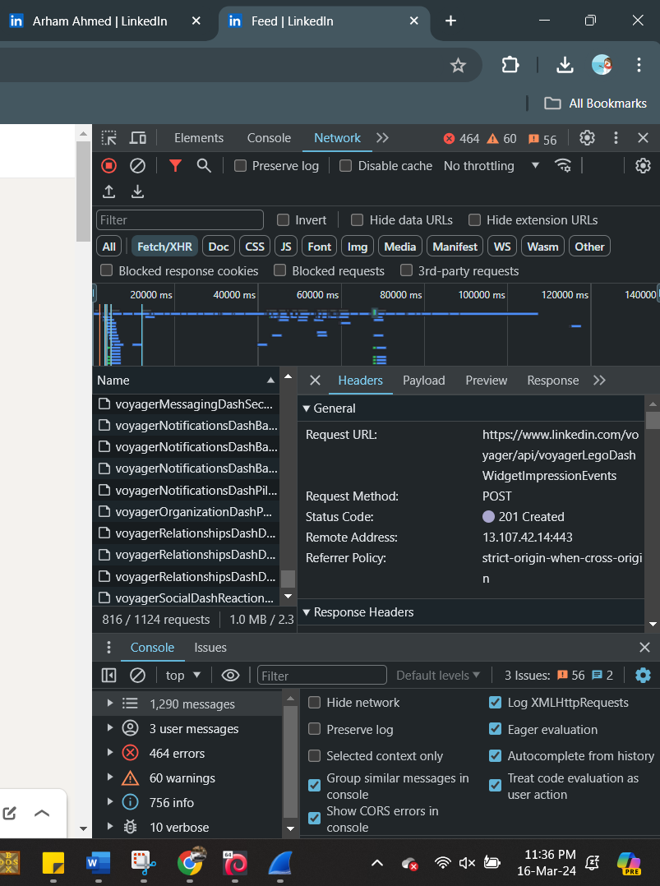

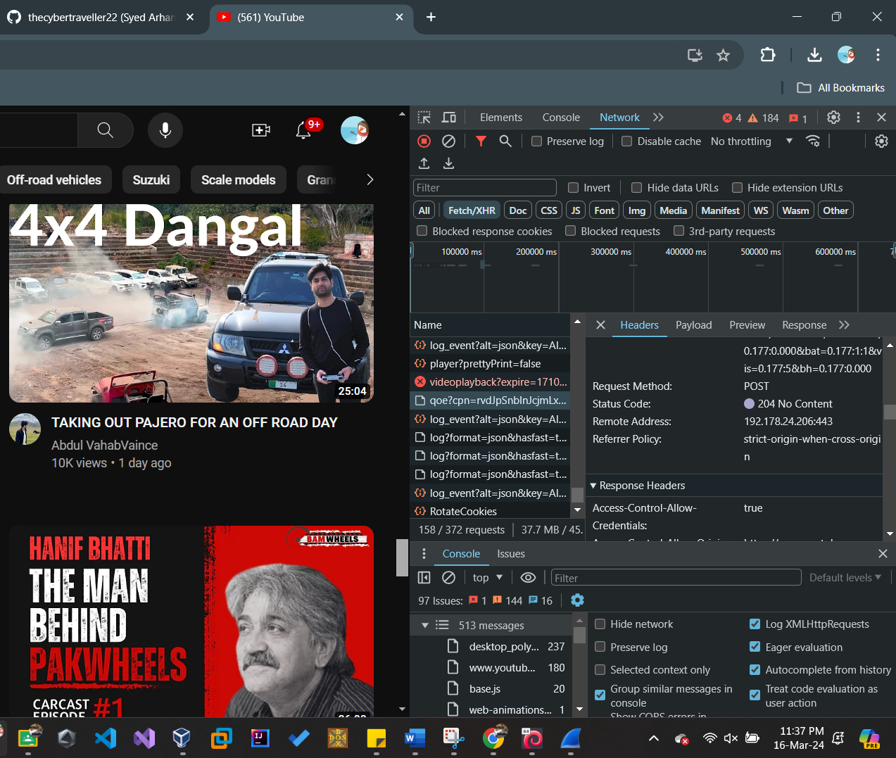

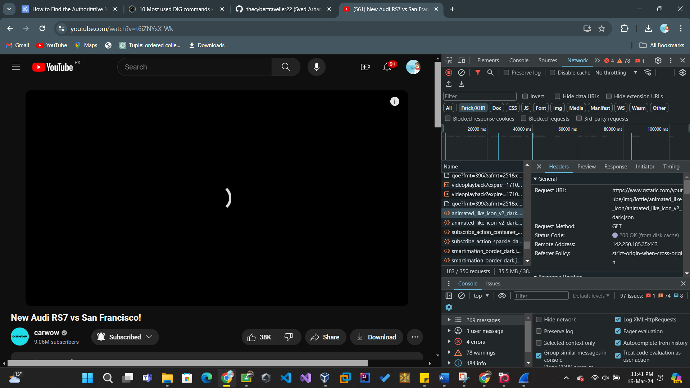

The above image shows us that it got the data from the cache instead of asking the DNS server.

